“Payment Gateway Services” PlayBook
EPR ID: 113309
Revised: 11/21/2011
Author: Jose Luis Medina

Contents
Version Control 3
Chapter 1 – Overview 4
Chapter 2 – Team & Vendor Elevation Process 6
Chapter 3 – Incident & Escalation Management 6
Section 3.0 – Performance Expectations – not yet approved by Steve 6
Section 3.1 – Information Gathering 6
Section 3.2 – Application Event Monitoring (AEM) Triage 6
Section 3.3 – Monitoring & Recovery: Job Recovery Procedure (JRP) 7
Section 3.4 – Failover Steps 7
Section 3.5 – Health Check Steps 8
Section 3.5.1 – Application Availability Verification 8
Section 3.5.2 – Server AVailability Verification 9
Section 3.5.3 – Web Server Availability Verification 10
section 3.5.4 – Database Availability Verification 10
Section 3.6 – Known Issues With Known Workarounds/Resolutions 11
Section 3.6.1 – Down Recovery Known Issues 11
Section 3.6.2 – Data Timeliness Known Issues 12
Section 3.6.3 – Poor Performance Known Issues 14
Section 3.7 – Down Recovery Actions 14
Section 3.7.1 – Restarting an Application 14
section 3.7.2 – Backup and Restore Actions 15
Section 3.7.3 – Post Escalation Involvement 15
Section 3.8 – Data Timeliness 16
Section 3.9 – Poor Performance 16
More information on PGS 17
What to do if the WL Admin console is not available 17
How to make sure the Node Manager is running and why I need it? 19
Starting or stopping a WebLogic Server Instance 19
How can I know which PID is used by each managed server? 20
What can I do if I can’t stop a server? 21
Restarting the Quova Service 21
Where can I find the FQM MessageBus logs? 22
Chapter 4 – Operations Management 25
Section 4.1 – Request Types 25
Section 4.1.1 – Request for Information 25
Chapter 5 – Change Management 26
Section 5.1 – How To Perform Changes 26

Version Control

Prepared by | Change | Date | Reviewed by | Date
Jose Luis Medina | Create IT Playbook Template | 20100913 | Steve Blesi / Debbie Carr | 20100616
Julio Hernandez | Playbook Update with Amy Dell’s notes from e-mail sent on May 6th for escalation HPIT-14762. For Application Availability Verification section | 20110530 | Jose Luis Medina | 7/7/2011
Jose Luis Medina | Update PGS health check URL and added notes on FQM being active-passive | 7/7/2011
Andres Lechuga | Added some notes to health check section and poor performance workaround. | 08/08/2011
Amy Dall | Added additional details | 9/1/2011 | Greg Andrews | 9/2/2011
Amy Dall | Added additional details for Payment.hp and DB Archive  Removed Jiaxi as a contact as he moved to a new team | 11/21/2011 | Greg Andrews | 11/21/2011
Amy Dall | Addition of CyberSource proxy alert troubleshooting steps | 4/8/2012

Chapter 1 – Overview
In all cases, we require a ticket to perform work. Clone the ticket the escalation manager is working from if needed and provide updates in the activity log documenting what you did. Remember to reflect the time you spent on an escalation in your time card.

Payment Gateway Services (PGS)
Criticality: Mission Critical
Payment Gateway Services-PGS provides credit card (auth, billing, credit, PayPal) services, CC real-time fraud screening services (RMS), and a fraud screening tool (FQM). PGS is used by multiple stores in AP, EMEA and NA. Impact would prohibit or delay credit card processing.
NOTE: New servers are in BOLD and ITALICS
Server Name | Environment | Description
g5w1071c.atlanta.hp.com | Production | Q-Listener (MSMQ)
g6w0544c.atlanta.hp.com | Production | Q-Listener (MSMQ)
gvw0982.americas.hpqcorp.net | Production | CLUSTER :: Q-Listener (MSMQ)
g5w1011c.atlanta.hp.com | Production | PGS DB Server
g6w0576c.atlanta.hp.com | Production | PGS DB Server
gvw1173.atlanta.hp.com | Production | PGS DB Cluster
gvv50016,2048 | Production | PGS SQL Virtual
g5w2224c.atlanta.hp.com | Production | PGS Archive DB Server
g6w1817c.atlanta.hp.com | Production | PGS Archive DB Server
gvw1790.americas.hpqcorp.net | Production | PGS Archive DB Cluster
gvv50623,2048 | Production | PGS Archive SQL Virtual
g5w1012c.atlanta.hp.com | Production | RMS/FQM SQL DB Server
g6w0574c.atlanta.hp.com | Production | RMS/FQM SQL DB Server
gvw1174.atlanta.hp.com | Production | RMS/FQM DB Cluster
gvv50017,2048 | Production | RMS / FQM SQL Virtual
g6w0330.atlanta.hp.com | Production | PGS WebServices
g6w0331.atlanta.hp.com | Production | PGS WebServices
g6w0332.atlanta.hp.com | Production | PGS WebServices
g5w2050.atlanta.hp.com | Production | PGS WebServices
g5w2051.atlanta.hp.com | Production | PGS WebServices
g5w2052.atlanta.hp.com | Production | PGS WebServices
vpgsws.atlanta.hp.com | Production | HWLB :: PGS WebServices
g6w0336.atlanta.hp.com | Production | PGS Admin
g6w0329.atlanta.hp.com | Production | PGS Admin
g5w2425.atlanta.hp.com | Production | PGS Admin
g5w2426.atlanta.hp.com | Production | PGS Admin
g5w1067.atlanta.hp.com | Production | PGS Admin
vpgsadmin.atlanta.hp.com | Production | HWLB :: PGS Admin
g4t7017.houston.hp.com | Production | FQM
g4t7018.houston.hp.com | Production | FQM
g9t5068.houston.hp.com | Production | FQM
g9t5069.atlanta.hp.com | Production | FQM
Vfqm4c1.houston.hp.com | Production | Houston 4 :: FQM
Vfqm9c1.houston.hp.com | Production | Houston 9 :: FQM
Vfqmc1.houston.hp.com | Production | HWLB :: FQM
g4t7014.houston.hp.com | Production | RMS Engine & RMS Admin server
g4t7015.houston.hp.com | Production | RMS Engine
g4t7016.houston.hp.com | Production | RMS Engine
g9t5065.houston.hp.com | Production | RMS Engine
g9t5066.houston.hp.com | Production | RMS Engine
g9t5067.houston.hp.com | Production | RMS Engine
Vrms4c1.houston.hp.com | Production | Houston 4 :: RMS Engine
Vrms9c1. houston.hp.com | Production | Houston 9 :: RMS Engine
Vrmsc1. houston.hp.com | Production | HWLB :: RMS Engine
g5w1072c.atlanta.hp.com | Production | Batch server
g6w0546c.atlanta.hp.com | Production | Batch server
gvw0983.atlanta.hp.com | Production | CLUSTER :: Batch
g5w1592c.atlanta.hp.com | Production | CVN DB Server
g6w1130c.atlanta.hp.com | Production | CVN DB Server
gvw1406.americas.hpqcorp.net | Production | CVN DB Cluster
gvv50155,2048 | Production | CVN SQL Virtual
g5w1591.atlanta.hp.com | Production | CVN Admin
g6w1129.atlanta.hp.com | Production | CVN Admin
vpgsCVN.atlanta.hp.com | Production | HWLB :: CVN Admin
g5w2617.atlanta.hp.com | Production | Payment.hp
g5w2618.atlanta.hp.com | Production | Payment.hp
g6w2343.atlanta.hp.com | Production | Payment.hp
g6w2344.atlanta.hp.com | Production | Payment.hp
vpayment5.atlanta.hp.com | Production | Atlanta 5 :: Payment.hp
vpayment6.atlanta.hp.com | Production | Atlanta 6 :: Payment.hp
phc.atlanta.hp.com | Production | GSLB:: Payment.hp
g5w2638c.atlanta.hp.com | Production | PGS_PHC SQL DB Server
g6w2355c.atlanta.hp.com | Production | PGS_PHC SQL DB Server
gvw2381.atlanta.hp.com | Production | PGS_PHC DB Cluster
GVV50792,2048 | Production | PGS_PHC SQL Virtual

Chapter 2 – Team & Vendor Elevation Process
Contact | Name | e-mail id | Cell Phone
Lead Dev Team | Andrews, Greg | greg.andrews@hp.com
Dev Team | Amy Dall | amy.dall@hp.com | 1-402-290-4366

Chapter 3 – Incident & Escalation Management

Section 3.0 – Performance Expectations – not yet approved by Steve
- Join the escalation call immediately.
- Join the virtual classroom, with name and function.
- Go on mute when not talking.
- Keep an eye on the clock – elevate consistently.
- Avoid side discussions and maintain a professional demeanor.
- Use the chat room for additional information.

Section 3.1 – Information Gathering
- HPIT Escalation Number
- Server(s) impacted (obtain cluster information if necessary)
- Application(s) impacted
- Database(s) impacted
- Server Environment (i.e. NGDC, RCS, Austin Purgatory, New Legacy)
- Check history of CI.
- Obtain a ticket to document your work to If you need to clone the ticket provide the ticket to the escalation manager.
- Run the configuration log collector on the affected server.
- If an analyst is unsure of the solution, communication with peers is encouraged as a first step. Someone else may have seen this issue.
- Web searches for solutions sometime yield results.

Section 3.2 – Application Event Monitoring (AEM) Triage

- PGS Health Status page
  - https://d9w0328g.houston.hp.com:7002/healthstatus/
- FQM Portal
  - https://vfqmc1.houston.hp.com
- RMS WebService (fraud screening)
  - https://vrmsc1.houston.hp.com/decision/entryservletxml
- RMS Admin (running on one server only)
  - https://g4t7014.houston.hp.com:30003/admin/login.jsp
- URL of WebLogic Consoles
  - https://g4t7017.houston.hp.com:30001/console
  - https://g9t5068.houston.hp.com:30001/console/
- PGS Admin/Report (used to check order status and info)
  - https://vpgsadmin.atlanta.hp.com/pgsreport/default.aspx
- PGS Admin/Report Archive (used to check order status and info for order older than 12 months)
  - https://vpgsadmin.atlanta.hp.com/pgsreport_archive/default.aspx
- PGS WebService (inbound credit card transactions)
  - https://vpgsws.atlanta.hp.com/PGSWebService/Inquire.asmx
- Payment.hp (tokenization interface)
  - https://phc.atlanta.hp.com/phc
  - NOTE: Expected result when going to this URL - Sorry, an error occurred while processing your request. This is not an issue!

Section 3.3 – Monitoring & Recovery: Job Recovery Procedure (JRP)

Master: Atlanta
Group: PGS
JRP procedure: http://prime.sharepoint.hp.com/teams/jrp/default.aspx

Section 3.4 – Failover Steps

All components of PGS are active-active but one: FQM
FQM is the only component active-passive
Failover is only available for FQM.

Houston 4 is primary site. In case a failover is needed, stop FQM cluster on Houston 4 (or the current active node) and start the cluster on the other Houston site.

Houston 4 WebLogic Console: https://g4t7017.houston.hp.com:7002/console
Houston 9 WebLogic Console: https://g9t5068.houston.hp.com:7002/console

Please make sure FQM portal only runs on one of the sites (Houston4 or Houston9). If you are not sure about this please engage Dev.

Use the same user name for both consoles: PGSRMSAdmin. Please look for the password on the KeyPass application.

Section 3.5 – Health Check Steps
Perform a health check consisting of the following checks:
List steps to be followed in order to restore services/application
Confirm “Active” servers are online and accessible
Confirm Database health
Confirm the following Websites are running only on active web server
Confirm Application Pools are running OK
Confirm Batch Asynch Services are running on Batch Server

List health check steps to verify services /application once restoration steps are completed
  - Open up Internet Browser
  - Connect to URLs listed above

Section 3.5.1 – Application Availability Verification
The following URL:

- https://g4t7014.houston.hp.com:30003/healthstatus/

It is hosted on a development environment, thus it could be off line while the application is working. It has been provided by development team as an aid and is NOT WITHIN SLA

A screen shot of how the health check should look when there are no issues is included below; also three important notes have been provided as well.

- Note that FQM is only running on Houston 4 servers.
- Note that RMSAdmin is running only on Houston 4 servers – RMSAdmin_g4t7014_1(g4t7014)
- RMS servers runs on both Houston 4 and Houston 9

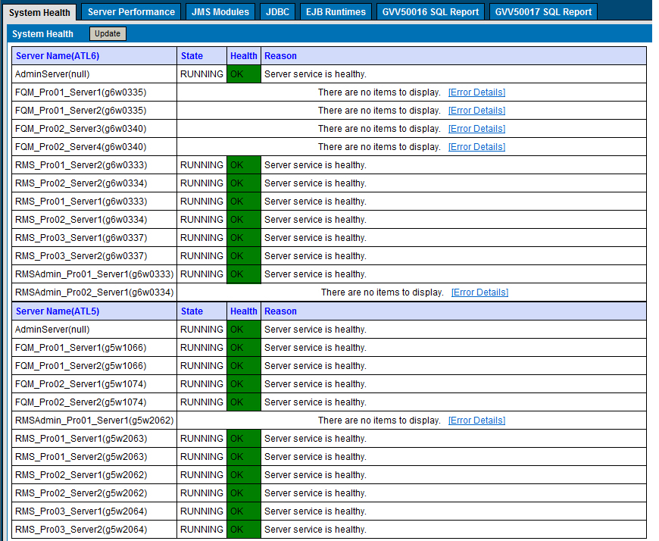

NOTE: If the Health Status Page above is not available, please go to the WebLogic Console - https://g4w7017.houston.hp.com:7002/console and https://g9w5068.houston.hp.com:7002/console/. From the left navigation go to Environment → Servers to ensure the appropriate servers (as highlighted above) are running with a health status of OK.

To ensure the application is work, please verify that all the following URLs are available.
- https://vfqmc1.houston.hp.com
- https://vrmsc1. houston.hp.com/decision/entryservletxml
- https://g4t7014. houston.hp.com:30003/admin/login.jsp
- https://g4t7017. houston.hp.com:30001/console
- https://g9t5068. houston.hp.com:30001/console/
- https://vpgsadmin.atlanta.hp.com/pgsreport/
- https://vpgsws.atlanta.hp.com/PGSWebService/Inquire.asmx

Section 3.5.2 – Server AVailability Verification
- Attempt a Remote Desktop Connection to servers listed above.
- After failing these basic connection attempts, engage Windows platform team. Let them know that the server is down and the connection attempts you have made.
- For RMS and FQM - If the server is available but the managed server will not start, please confirm the E:/ Drive is available. If not, engage the Windows platform team.

Section 3.5.3 – Web Server Availability Verification
Open IIS and verify the IIS and application pool are running as expected.
g6w0330.atlanta.hp.com | Production | PGS WebServices
g6w0331.atlanta.hp.com | Production | PGS WebServices
g6w0332.atlanta.hp.com | Production | PGS WebServices
g5w2050.atlanta.hp.com | Production | PGS WebServices
g5w2051.atlanta.hp.com | Production | PGS WebServices
g5w2052.atlanta.hp.com | Production | PGS WebServices
PCI 4.0
g4w8269.houston.hp.com | Production | PGS WebServices
g4w8270.houston.hp.com | Production | PGS WebServices
g4w8271.houston.hp.com | Production | PGS WebServices
g9w7547.houston.hp.com | Production | PGS WebServices
g9w7548.houston.hp.com | Production | PGS WebServices
g9w7549.houston.hp.com | Production | PGS WebServices

g6w0336.atlanta.hp.com | Production | PGS Admin
g6w0329.atlanta.hp.com | Production | PGS Admin
g5w1067.atlanta.hp.com | Production | PGS Admin
PCI 4.0
g9w8278.houston.hp.com | Production | PGS Admin
g9w8277.houston.hp.com | Production | PGS Admin
g4w8903.houston.hp.com | Production | PGS Admin
g4w8904.houston.hp.com | Production | PGS Admin

Check the URLs for PGS WebService and PGS Admin
- https://vpgssitec2.houston.hp.com/PGSReporting
- https://vpgswsc1.houston.hp.com/PGSWebService/Inquire.asmx

section 3.5.4 – Database Availability Verification
Contact GDBA MS SQL Server, to check the health of the following database SQL servers:
Databases:

- GVV50016
  - Paymentgateway
  - paymentgateway_archive
  - pgs_errLog
  - PGS_Report
  - PGS_Report_a.

- GVV50017
  - DMCEAdmin
  - DMCEDecision
  - FQM
  - FqmQuartzrchive
- GVV50623
  - PaymentGateway_Archive (only active DB at this time)
- GVV50792
  - PGS_PHC

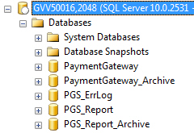
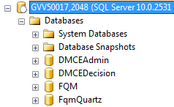
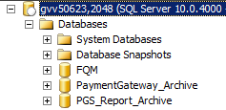
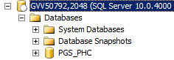

PCI 4.0
- GVV41626.houston.hp.com,2048
  - Paymentgateway
  - PGS_PMIS
  - pgs_errLog
  - PGS_Report
  - PGS_Report_a.
  - PGS_RD
  - PGS_RDXL

- GVV41627.houston.hp.com,2048
  - DMCEAdmin
  - DMCEDecision
  - FQM
  - FQM_UAM
  - FqmQuartzrchive
- GVV41621.houston.hp.com,2048
  - PaymentGateway_Archive (only active DB at this time)
- GVV41623.houston.hp.com,2048
  - PGS_PHC
- GVV41622.houston.hp.com,2048
  - PGS_CVN

Section 3.6 – Known Issues With Known Workarounds/Resolutions
Following are workarounds for known issues.

Section 3.6.1 – Down Recovery Known Issues
PGS RMS Admin goes down.
URL: https://g4t7014.houston.hp.com:30003/admin/login.jsp
Issue is with one managed server. You can use the Houston 4 WebLogic Console to stop and start.
Console: https://g4t7017.houston.hp.com:30001/console
Stop and start: RMSAdmin_Pro01_Server1
IF the managed server will not shutdown,
- Log onto g4t7014.houston.hp.com
- Switch to user rmsfqm
- Execute command ps –ef | grep RMSAdmin to check PID of RMSAdmin Managed Server
- Kill process of RMSAdmin Managed Server using command kill <PID>
NOTE: Do NOT kill any other java.exe processes as you will impact real-time fraud handling.

Section 3.6.2 – Data Timeliness Known Issues
SVS data timeliness issues.
Error Message
Orders are showing as SentSVS status on PGS site and it's been more than 5 days since the send to SVS.
Cause: SVS third party service provider did not send the affected orders to PGS.
This only affects HHO at this time.
HHO normally provides affected orders.
Cause
Possible failure when connecting to SVS SFTP or SVS did not provided the orders on any files.
Workaround / Fix
Open database connection to gvv41626.houston.hp.com,2048
use PaymentGateway
select
* from dbo.tb_PG_SVS_PhysicalOrder where MasterOrderNumber in
(
'H110536954',
'H110542777',
'H110008757'
)
select
* from dbo.tb_PG_SVS_PhysicalOrder where
datepart
(yyyy,inserteddatetime)=2010 and
datepart

On the results you will see the affected orders (MasterOrderNumber) with status (OrderStatus) = SentSVS.
This means that we sent the orders to SVS but they have not replied back. They do so with a file we pick up on SFTP. If orders are in fact SentSVS, contact SVS for information:
Starkey, Vicki: VStarkey@storedvalue.com
Kreimborg, Scott: skreimborg@storedvalue.com
Ask about the orders using the MasterOrderNumber. Once they reply saying the file is ready for pick up, log in to the server: gvw0753.atlanta.hp.com
Go to folder: F:\PGSApp\PGSReconciliationPlatform\Reconciliation.Files\Task
run: SVS.RevOrderConfirm.bat
This will resolve the issue. Once it completes. Check database, you should see OrderStatus=SVSConfirmed
after a few minutes (3 minutes); HHO will query the orders and the order should change to SFConfirmed, which resolves the issue.
If after you run the task again the orders are still SentSVS, ask SVS again about the orders because the affected orders were not included on the file.
(mm,inserteddatetime)>=1

FQM data timeliness issues.
Error Message
New orders are not displaying in the FQM Portal. Typically reported by Credit and Collections
Cause: FQM Quartz Job has stopped responding
This impacts HHO and ISCS.
Credit and Collections normally provides impacted orders.
Cause
FQM Quartz Job has stopped responding.
Workaround / Fix
Restart the FQM Managed Servers – rolling restart
Houst 4 is primary site.

In case a restart, stop 2 managed servers in the FQM cluster on Houston 4 (or the current active node) and start the 2 managed servers in the FQM cluster on the same Houston site. Once the first 2 managed servers are running, then shut down the other 2 managed servers in the FQM cluster on the same Houston site and start the 2 managed servers in the FQM cluster on the same Houston site.

Houston 4 WebLogic Console: https://g4t7017.houston.hp.com:30001/console
Houston 9 WebLogic Console: https://g9t5068.houston.hp.com:30001/console

Please make sure FQM Portal only runs on one of the sites (Houston 4 or Houston 9). If you are not sure about this please engage Dev.

Use the same user name for both consoles: PGSRMSAdmin. Please look for the password on the KeyPass application.

RMS orders are processing; however, no new orders can be found in FQM
Error Message
RMS orders are processing without issue; however, agents are reporting no new orders are found in FQM.
This impacts HHO and ISCS.
Credit and Collections normally provides impacted orders.
Cause
RMS OtfBrokerPersisterMDBQueue job has stopped working.

To confirm,
- Go to the PGS System Health Status Page (https://g4t7014.houston.hp.com:3003/healthstatus/)
- Go to the JMS Modules Tab
- Click Update to check the pending messages on the rms_queue_module – OtfBrokerPersisterMDBQueue
- If there are several messages pending and they are highlighted on the PGS System Health Status Page, then there is an issue with RMS persisting the orders to the FQM database.

Workaround / Fix

Restart the RMS Managed Servers – rolling restart per site
NOTE: RMS is active/active so you can restart an entire site at a time. However, ensure the site is showing a good health status before restarting the second site.

In case a restart, stop (Shutdown When Work Completed) all 6 managed servers in the RMS cluster on Houston 4. Once all RMS managed servers are shutdown, start all 6 managed servers in the RMS cluster on Houston 4. Once the servers indicate they are all running, go to the Environment → Servers Link on the Left Nav to confirm all servers show a status of OK.

Once all RMS managed servers in Houston 4 are running ok, then repeat the process to restart the RMS managed servers in Houston 9. Stop (Shutdown When Work Completed) all 6 managed servers in the RMS cluster on Houston 9. Once all RMS managed servers are shutdown, start all 6 managed servers in the RMS cluster on Houston 9. Once the servers indicate they are all running, go to the Environment → Servers Link on the Left Nav to confirm all servers show a status of OK.

After all RMS managed servers have been restarted, go back to the PGS System Health Status Page and confirm the messages on rms_queue_module – OtfBrokerPersisterMDBQueue are going down.

Houston 4 WebLogic Console: https://g4t7017.houston.hp.com:30001/console
Houston 9 WebLogic Console: https://g95068.houston.hp.com:30001/console

Use the same user name for both consoles: PGSRMSAdmin. Please look for the password on the KeyPass application.

CyberSource ([PGS Service Error] ---- CYBS) Alerts Regarding Unable to connect to the remote server
Error Message
More than 40 CyberSource email alerts are received from PGSService_DCC_PRO@hp.com within a 10 minute period with the following error message listed in the body of the email:

Unable to connect to the remote server ---> System.Net.Sockets.SocketException: A connection attempt failed because the connected party did not properly respond after a period of time, or established connection failed because connected host has failed to respond
Cause
More than likely, the HP proxies are unavailable

NOTE: This issue will impact CyberSource credit card transactions, 3rd party callouts in RMS and FQM, and recon.
Workaround / Fix
PGS is using the proxyha.houston.hp.com:8080 proxy setting.
Create an urgent IM ticket for the proxy team (CI hpit:w-fwdproxy-prd) to check if there is an issue with the proxy address listed above. If no one has responded to the IM ticket with the SLA AND email alerts continue to be received (wait no more than 30 minutes), escalate the ticket to get immediate assistance.
NOTE: PGS is in the PCI IBA compartment, so IF the proxy team indicates there is no issue, please confirm if any server or hardware changes have been implemented. IF new hardware was added, please confirm if the appropriate firewalls were opened to allow the PCI IBA servers to communicate to the new servers.

CyberSource ([PGS Service Error] ---- CYBS) Alerts Regarding Payment processor error
Error Message
More than 40 CyberSource email alerts are received from PGSService_DCC_PRO@hp.com within a 10 minute period with one of the following error messages listed in the body of the email:

Payment processor error (91) Card issuer temporarily not reachable
OR
We encountered a Paymentech problem: Reason: The issuer for this transaction did not respond.
OR
Payment processor error (83) Authorization center not available for 300 seconds

Cause
More than likely, CyberSource is unable to connect to the appropriate processor at this time.

Workaround / Fix
Contact CyberSource Support to determine if there is a known issue and what their ETA for resolution is.
CyberSource Support contact information –
premier_support@cybersource.com
1-888-417-2230

Section 3.6.3 – Poor Performance Known Issues
No poor performance known issues

Section 3.7 – Down Recovery Actions

Section 3.7.1 – Restarting an Application
If web servers are not responding we need to request to DWH to restart IIS on web servers:
g6w0330.atlanta.hp.com | Production | PGS WebServices
g6w0331.atlanta.hp.com | Production | PGS WebServices
g6w0332.atlanta.hp.com | Production | PGS WebServices
g5w2050.atlanta.hp.com | Production | PGS WebServices
g5w2051.atlanta.hp.com | Production | PGS WebServices
g5w2052.atlanta.hp.com | Production | PGS WebServices
Check the URLs for PGS WebService
- https://vpgsws.atlanta.hp.com/PGSWebService/Inquire.asmx
- PCI 4.0
g4w8269.houston.hp.com | Production | PGS WebServices
g4w8270.houston.hp.com | Production | PGS WebServices
g4w8271.houston.hp.com | Production | PGS WebServices
g9w7547.houston.hp.com | Production | PGS WebServices
g9w7548.houston.hp.com | Production | PGS WebServices
g9w7549.houston.hp.com | Production | PGS WebServices
Check the URLs for PGS WebService
- https://vpgswsc1.houston.hp.com/PGSWebService/Inquire.asmx

If PGS Admin is not responding we need to request to DWH to restart IIS on web servers:
g6w0336.atlanta.hp.com | Production | PGS Admin
g6w0329.atlanta.hp.com | Production | PGS Admin
g5w1067.atlanta.hp.com | Production | PGS Admin
Check the URLs for PGS Admin
- https://vpgsadmin.atlanta.hp.com/pgsreport/

PCI 4.0
g9w8278.houston.hp.com | Production | PGS Admin
g9w8277.houston.hp.com | Production | PGS Admin
g4w8903.houston.hp.com | Production | PGS Admin
g4w8904.houston.hp.com | Production | PGS Admin
Check the URLs for PGS Admin
- https://vpgssitec2.houston.hp.com/pgsreporting/

Weblogic
Check the PGS status page:
- https://g4t7014.houston.hp.com:30003/healthstatus/
System health should as this:

NOTE: If the Health Status Page above is not available, please go to the WebLogic Console - https://g4t7017.houston.hp.com:30001/console and https://g9t5068.houston.hp.com:30001/console/. From the left navigation go to Environment / Servers to ensure the appropriate servers (as highlighted above) are running with a health status of OK.

NOTE: FQM should typically only be running in Houston 4.
FQM in Houston 9 should not be running if active node is Houston 9.
When failover is done on FQM, the active node will be running on Houston 9.
Important to remember is that FQM must be running on ONLY ONE SITE. Not both at the same time.
All other servers are Active/Active.

When restarting RMS servers you must make sure the servers are not forcibly shutdown. Graceful shutdown must be used. This will let the managed server to complete to process current orders. Not using correct shutdown can cause data timeliness issues

section 3.7.2 – Backup and Restore Actions
No restore actions.

Section 3.7.3 – Post Escalation Involvement
After involvement in an escalation, it is vital that management is informed of what issues were discovered and what actions were taken to resolve these issues. Also, if any changes were made to the backup environment in order to resolve any issues, the backup team member is responsible to restore the environment to its previous state (i.e. migrate clients back to their correct cell server, remove dummy backups, etc.).
Summary checklist
Escalations can be a high pressure situation because of the impact a down application/server can have on HP. In an escalation, it is important to stay calm and make rational decisions. The following checklist should guide you in the event of an escalation.
- Be available in the ITOC virtual room and join any escalation event rooms/conference calls if requested.
- Contact Kenneth Brown if the business continuity is dependent of backup team tasks or if a higher level of support is required.
- Gather information pertaining to the issues in order to perform backup/restore related activities and make a recommendation to get business continuality restored.
- In the case or a restore, ensure that all media needed is available. The general rule of thumb is that you request all media from the full backup session and every subsequent incremental backup session. If the media is not available, make needed request to the media team.
- Perform required tasks.
- Continue to communicate with escalation event room/conference call if necessary, notify with backup/restore tasks are complete, and ensure that data was validated.
- Track restores if one was performed.
- Update management post escalation and restore backup environment to its previous state.

Section 3.8 – Data Timeliness
No data timeliness instructions.

Section 3.9 – Poor Performance
A common issue for PGS is that FQM portal stops working.
The URL https://vfqmc1.houston.hp.com/fqm/LoginRequired.do?banner=false shows a network error message on IE7 and the users report that are not able to log in.
Health check page: https://g4t7014.houston.hp.com:30003/healthstatus/ may or may not show issues with these servlets
- FQM_g4t7017_1
- FQM_g4t7017_2
- FQM_g4t7018_1
- FQM_g4t7018_2
To solve this issue, FQM services must be restarted.
Procedure:
- Using : https:// g4t7014.houston.hp.com:30003/healthstatus/ confirm on what site are the FQM servlets running, either Houston 4 or Houston 9.
- Log to either Houston 4or Houston using the appropriate of these URLs, you can find the credentials at Key Pass
  - https://g4t7017.houston.hp.com:30001/console
  - https://g9t5068.houston.hp.com:30001/console
- In the left bar, click on RMS_FQM_domain or RMS_FQM_domain depending on which server you are logged.
- On the main content sections click on “control” tab
- Check the following server instances
  - FQM_g9t5068_1
  - FQM_g9t5068_2
  - FQM_g9t5069_1
  - FQM_g9t5069_2
- From the top or bottom pull down menus, select “Force Shutdown Now”.
If the reset fails, the appropriate java.exe instance must be killed, this procedure is found below, in the section “HOW CAN I KNOW WHICH PID IS USED BY EACH MANAGED SERVER?”
- When the server stops, check all again and click on start button at bottom or top of the server list in the main content area.
- Done

More information on PGS

What to do if the WL Admin console is not available
If the WL Admin Console is not available when trying the correct URL, you need to verify the Admin Console service is running. Only the Admin Console and the Node Manager are running as windows services. The WL Admin Console is a single service running on one machine in Houston 4 (g4t7017.houston.hp.com) and one machine in Houston 9 (g9t5068.houston.hp.com)

Houston 4 URL: https://g4t7017.houston.hp.com:30001/console/
Houston 9 URL: https://g9t5068.houston.hp.com:30001/console
To Restart the WebLogic Console Service:
NOTE: This will NOT impact the credit card processing. This is recommended for when you see the WebLogic Console running slow or unavailable. This is also recommended after any database failover to ensure all managed servers are communicating with the WebLogic Console.
- Log onto the appropriate server - Houston 4 (g4t7017.houston.hp.com) or Houston 9 (g9t5068.houston.hp.com)
- Go to Script path → /opt/sasuapps/rmsfqm/support/script
- Execute command sh stop_weblogic_console.sh to stop weblogic console
- Execute command sh start_weblogic_console.sh to start weblogic console

Please note that the URL will not be accessible if you are not using SSL ports. ALL PGS IS ONLY ACCESSIBLE ON SSL PORTS.

How to make sure the Node Manager is running and why I need it?
The Weblogic Admin Console is used to start any managed server. The only dependency we have for the Admin Console to start the server is the Node Manager. To control a Managed Server from the console, Node Manager must be configured and running on the machine where the Managed Servers are installed.
To check the Node manager is running, you need to log to each one of the machines and verify on the windows service that you can see the service: Node Manager as started.

Starting or stopping a WebLogic Server Instance
Controlling the servers is done from the console. This is done on the Control tab of the servers, the clusters or the domain.
Depending on what you need to do is which Control tab you can open. For example, if you need to restart only FQM Cluster, you can go to Cluster. If you need to restart RMS and FQM Clusters, you can go to domain. If you need to restart only one server, you can open the control tab on that server.

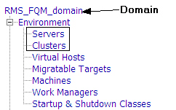
You will see the same under control tab. On this screen, you can control the server.
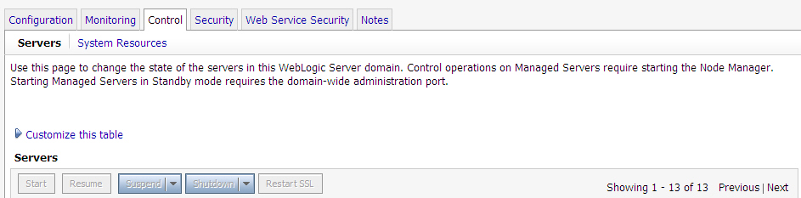

Start
Moves server instances from the SHUTDOWN state to RUNNING.
Resume
Moves server instances from the STANDBY or the ADMIN state to RUNNING.
Suspend servers when work completes
Moves server instances from the RUNNING state to the ADMIN state, allowing work in process to be handled gracefully. While in the SUSPENDING state, Work Managers complete in-flight processing for pending work in application threads.
Forcibly suspend servers
Immediately moves server instances from the RUNNING state to the ADMIN state, without handling work in process gracefully.
Shutdown servers when work completes
Gracefully stops server instances in the domain. New requests are rejected but in-work requests are completed before the server stops.
Forcibly shutdown servers
Immediately stops server instances in the domain. In-work requests are dropped, no new requests are accepted, and the server immediately stops.
Restart SSL
Restarts the SSL listen sockets so that keystore changes take effect.
Please note that Forcibly shutdown servers is not the preferred method.
To start or stop a server, select the server you want to control and click on the button you need. A new screen will be displayed asking for confirmation. Proceed if you have the proper approvals from SDM.
After the stop or restart process is started, you need to wait for a couple of minutes until the server stops or restarts. If you are restarting the server, please make sure the server starts with Health OK. (Please refer to FAQ 13)

How can I know which PID is used by each managed server?
Each managed server is running on one machine. You need to know first what is the machine being used by that managed server.
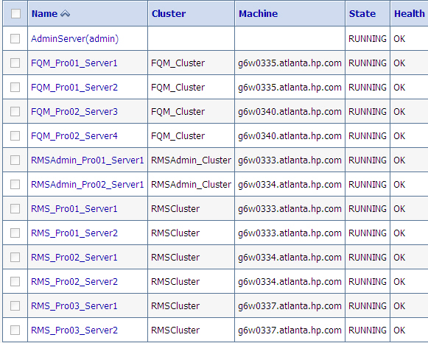
Once you know what is the server name, you need to go to the folder:
\\serverMachine\servers\ServerName\data\nodemanager\ServerName.lck
Note: the bolded words are variables.
For example:

\\g6w0335\servers\FQM_Pro01_Server1\data\nodemanager\FQM_Pro01_Server1.lck
serverMachine: g6w0335
ServerName: FQM_Pro01_Server1
Inside this file, you will find the PID.

What can I do if I can’t stop a server?
You need to kill the process. Kill it by PID. Refer to section 2.9 on how to get the PID.
Open the Task Manager. Look for the PID found on previous section. Confirm the process is a java.exe (64 bits) with more than 1GB of RAM being used.
Kill the process.

Restarting the Quova Service
Problem: The Quova service is either not running or needs to be restarted.
Solution: Go to Control Panel, Administrative Tools, Services. Locate the service named ‘GeoDirectory6.1’ and start the service. You can tail the e:\Program Files\Quova\GeoDirectory6.1\log\quovaserver.log log file in order to check the progress of this operation.
If the Quova service was restarted successfully, you should be able to obtain the following output after executing this command:
C:\Program Files\Quova\GeoDirectory6.1\bin>serverStats.exe
Memory Free: 217865376
Memory Used: 355119968
Queries: 49556

Where can I find the FQM MessageBus logs?
Problem: FQM had problems while sending an update (communicating) with MessageBus. We need to determine what went wrong.
Solution: Go to C:\opt\fqm\logs\MessageBusRequest.errorLog. In this file you should be able to find the actual message(s) for which we had problems communicating with MessageBus. A special tool provided by the dev team should allow us to parse this log file, extract the actual message and resend it to MessageBus.
Problem: You receive an alert titled ‘“[PGS Message Bus Error]-MessageTransactionID:0341ddaf-7c9b-4bf1-a766-fc59d606c01d”’
Solution: Open the email message and look for the error description (should be in the ‘ErrorDetail’ element of the message

[Error Information]
[Server Name]CCEPGSBSPR01[Server Name]
[Error DateTime]12/14/2006 8:26:01 AM[Error DateTime] <PGSMessageBusError>
<ErrorCode>2001</ErrorCode>
<MessageTransactionId>0341ddaf-7c9b-4bf1-a766-fc59d606c01d</MessageTransactionId>
<Message>Fail to process request message.You could retry, if problem still exists, please contact PGS Support Team.Your request message has been backuped in PGSMessageBus waitfing for manually process. </Message>
<ErrorDetail>Exception Detail:Failed to execute StoreProcedure:
DataBase:PaymentGateway
StoreProcedure:usp_PG_MB_SaveMessage
ErrorMessage:The log file for database 'PaymentGateway' is full. Back up the transaction log for the database to free up some log space.
</ErrorDetail>
<StackTrace> at System.Data.SqlClient.SqlCommand.ExecuteReader(CommandBehavior cmdBehavior, RunBehavior runBehavior, Boolean returnStream)
at System.Data.SqlClient.SqlCommand.ExecuteScalar()
at HP.eBusinessIT.PGS.MessageBus.SqlFuncs.ExecuteScalar(SqlConnection connection, CommandType commandType, String commandText, SqlParameter[] commandParameters)
at HP.eBusinessIT.PGS.MessageBus.SqlFuncs.ExecuteScalar(String connectionString, CommandType commandType, String commandText, SqlParameter[] commandParameters)
at HP.eBusinessIT.PGS.MessageBus.LogMessageSink.ProcessMessage(MessageWrapper wrapper, Boolean isReceive)</StackTrace> </PGSMessageBusError>

[Request Xml]:
<pgs:FQMOrderUpdate xmlns:pgs="http://www.hp.com/ecoit/pgs/FQMOrderUpdateRequest.xsd"><pgs:FromRole><pgs:GlobalPartnerClassificationCode>e0401f5394314a80846a9c57a401bed6</pgs:GlobalPartnerClassificationCode><pgs:GlobalBusinessIdentifier>200671115210</pgs:GlobalBusinessIdentifier><pgs:PGSMerchantID>hp_rms_fqm</pgs:PGSMerchantID></pgs:FromRole><pgs:FQMOrderResult><pgs:OrderNumber>1374-0452717-013</pgs:OrderNumber><pgs:TxnID /><pgs:OrderState>ACCEPT</pgs:OrderState><pgs:ReasonCode /><pgs:RmRCode>0</pgs:RmRCode><pgs:RuleCode>30</pgs:RuleCode><pgs:Comment /><pgs:AnalystID /><pgs:BusinessID>aspherio</pgs:BusinessID><pgs:RMSOrderId>752540</pgs:RMSOrderId></pgs:FQMOrderResult></pgs:FQMOrderUpdate>
If the problem is DB or network related, please troubleshoot accordingly. If it’s a problem related to the MessageBus per se, then please contact the DEV team.
When these errors occur, a copy of the affected request XML messages will stored on the Batch Server(s) at directory
F:\PGSWebRoot\PGSMessageBus\BackupMessage

In order to process these affected messages, we’ll need to manually reprocess them by using the MessageBusTool located at
F:\PGSWebRoot\PGSMessageBus\MessageBusTool\MessageBusTool.exe
Once you run this tool, you’ll be presented with something similar to this:
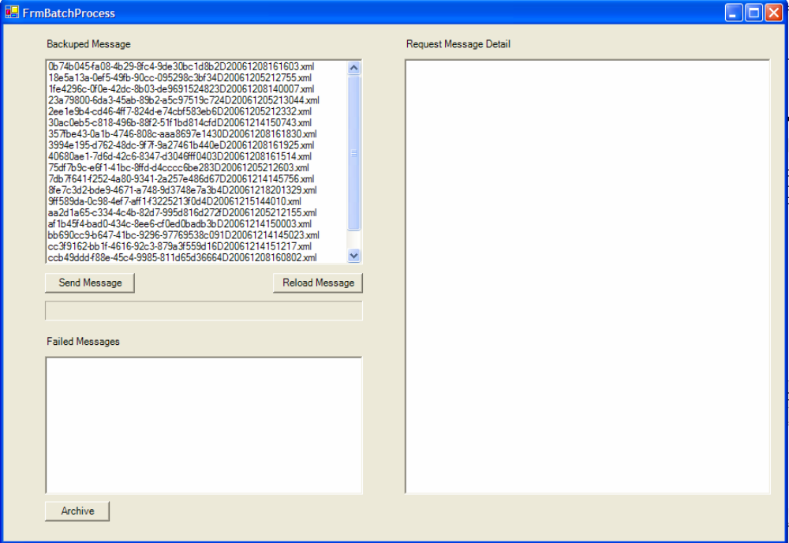
Once the tool is open a list of all ‘stuck’ messages will be displayed in the ‘Backuped Message’ window pane. Select all messages you wish to reprocess and click the ‘Send Message’ button and all messages should be sent to the PGS MessageBus. If the reprocessing was successful, you’ll see the following:
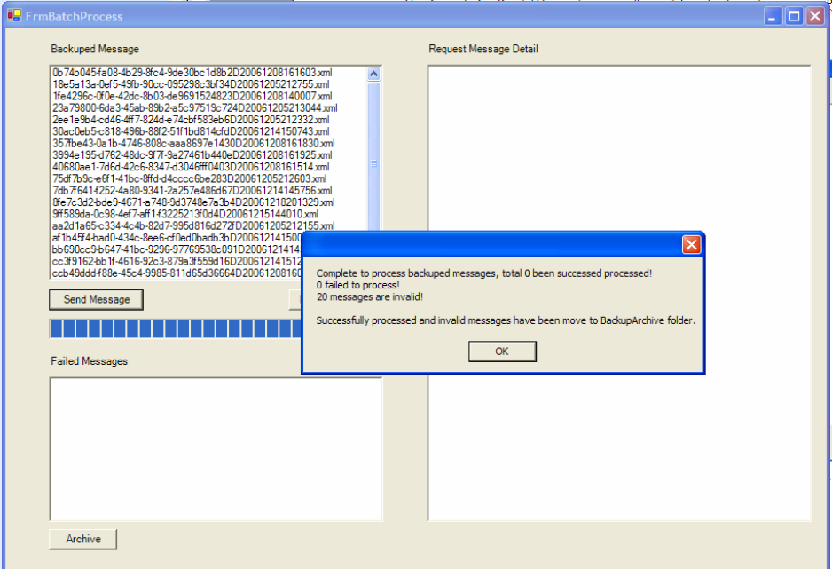

If there was any problem while attempting to reprocess failed messages, go to
F:\PGSWebRoot\\PGSMessageBus\BackupArchive\
and look for files named like
“Failed_9376f8b9-adfc-4bb0-974b-9e09f7e1a62cD20061031224315.xml”
Send these failed files to Dev Team such that they can take a look into this.
NOTE: If you receive error messages similar to the following:
- The underlying connection was closed: Unable to connect to the remote server.
- The request failed with HTTP status 403: Forbidden.
Make sure that IE’s proxy setting is web-proxy.atlanta.hp.com port 8080 and try to run the tool again.

Chapter 4 – Operations Management

Section 4.1 – Request Types

Section 4.1.1 – Request for Information
No incidents received so far.

Chapter 5 – Change Management

Section 5.1 – How To Perform Changes

Normal change process

